Animesh Parab T2-T21 88

ASSIGNMENT-9

AIM:- To understand AWS Lambda functions

LO MAPPED: LO1, LO5

THEORY:
AWS Lambda is a serverless compute service provided by Amazon Web Services (AWS) that enables you to run code in response to various events without the need to manage servers. It's a key component of AWS's serverless computing offerings. To understand the theory behind AWS Lambda functions, let's break it down into its core concepts:
Serverless Computing:
Serverless computing is a cloud computing model where cloud providers (like AWS) manage the infrastructure for you, allowing you to focus solely on your code.
Lambda Function:
A Lambda function is the fundamental unit of execution in AWS Lambda. It is a piece of code that can be executed in response to events such as HTTP requests, file uploads, database changes, etc. Lambda supports multiple programming languages, including Node.js, Python, Java, and more.
Event Sources:
Lambda functions are triggered by events. These events can come from various AWS services, like Amazon S3, Amazon DynamoDB, Amazon API Gateway, or custom events from your applications. Lambda listens to these event sources and automatically executes the code you've configured.
Stateless Execution:
Lambda functions are stateless, meaning they don't maintain any server-specific state between invocations. Each invocation of a Lambda function is independent and isolated from the others.
Scaling and Concurrency:
AWS Lambda automatically scales based on the number of incoming events. If there are more events, AWS will create more instances of your Lambda function to handle the load, and if there are fewer events, it will scale down accordingly. You pay only for the compute time your code consumes.
Execution Environment:
Each Lambda function runs in an execution environment provided by AWS. You can't control or manage this environment, but you can specify its configuration, including the amount of memory allocated to the function.
Function Versioning and Aliases:
You can create multiple versions of a Lambda function. This is useful for deploying and managing different versions of your code. You can also create aliases to point to specific versions, allowing you to easily switch between them.
IAM Roles:
Lambda functions can assume AWS Identity and Access Management (IAM) roles. These roles define what AWS services and resources the function can interact with, ensuring proper security and access control.
Logging and Monitoring:
AWS Lambda provides built-in logging to capture function execution details. You can also integrate it with AWS CloudWatch for monitoring and creating custom metrics.
Triggers and Destinations:
Lambda can be triggered by various event sources and can send the results to destinations such as other AWS services, like S3, DynamoDB, SNS, and more.
STEPS:
Login to Aws account-
Search S3 ,click on the option below shown-
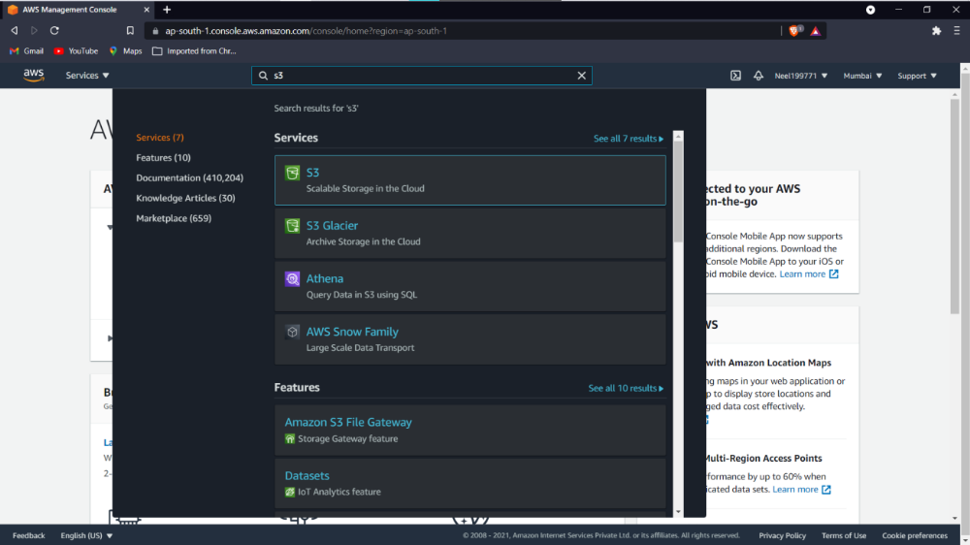
Create an S3 bucket by giving it a name
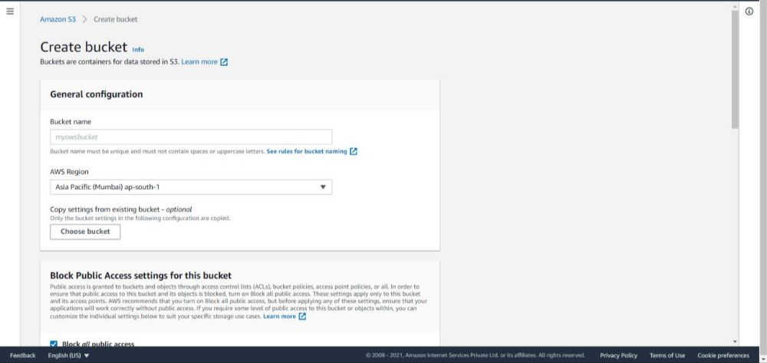
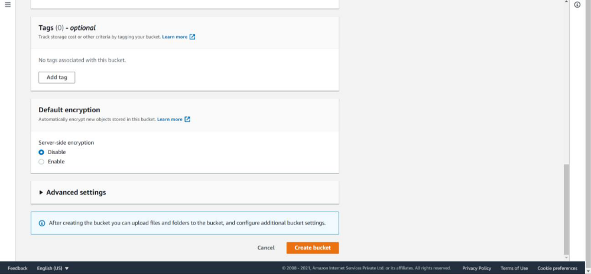
Click on upload button after the s3 bucket is created in the object section
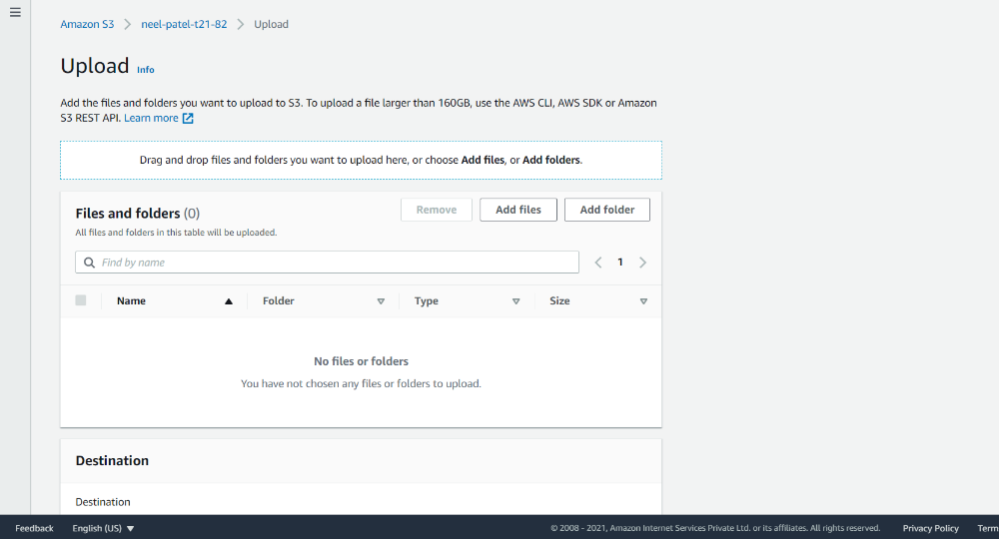
Add any .py or .java extenstion file and click on upload
Now search
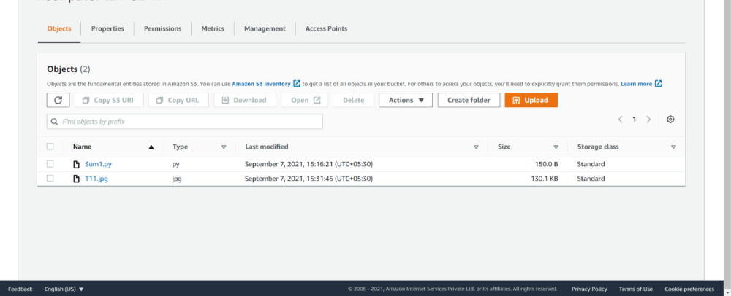
Now search Lamda
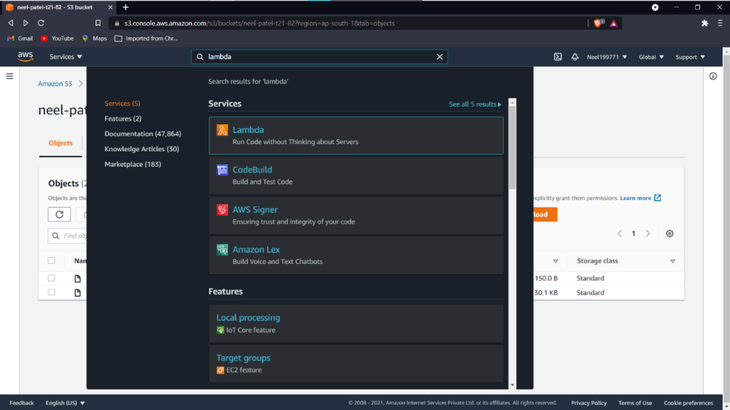
Click create function
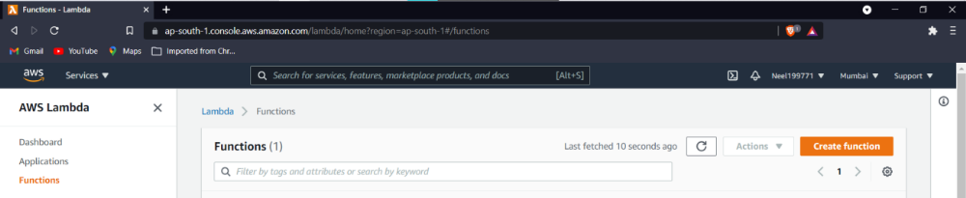
Click on below options and click on configure
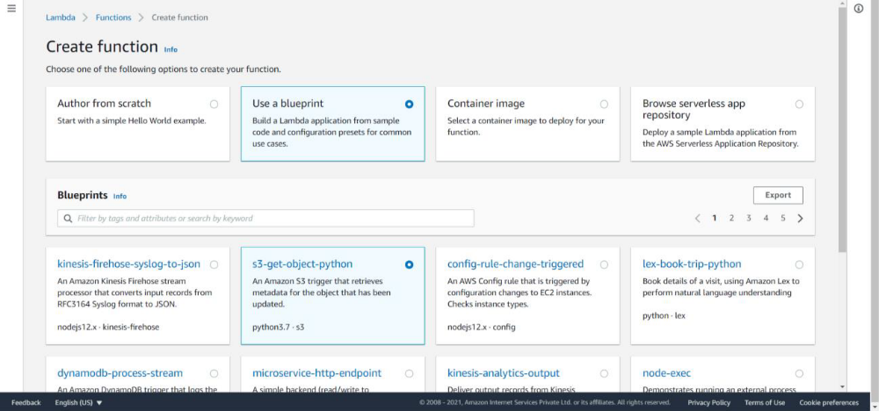
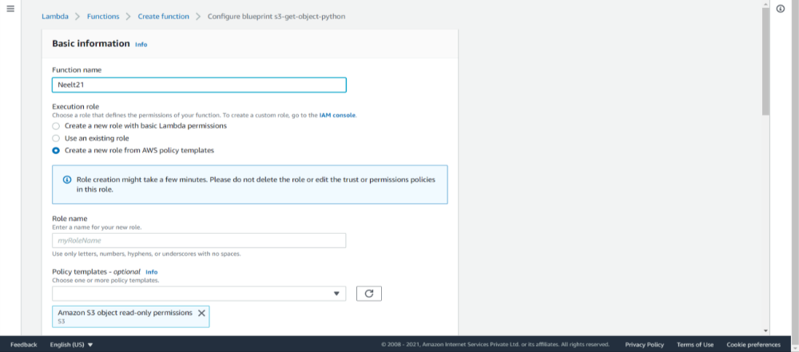
Select the bucket created and create trigger ,click on create function-
Check the given trigger is created
Click on
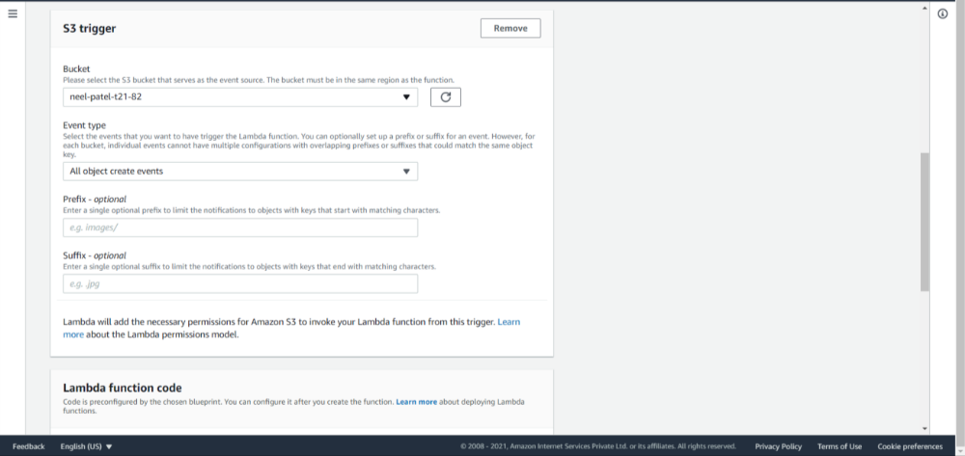
Check the given trigger is created
Click on

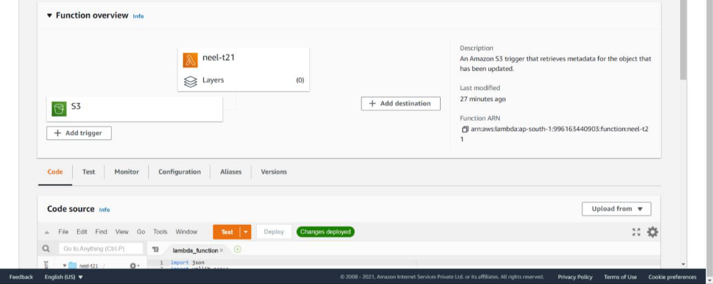
Click on the orange test button-
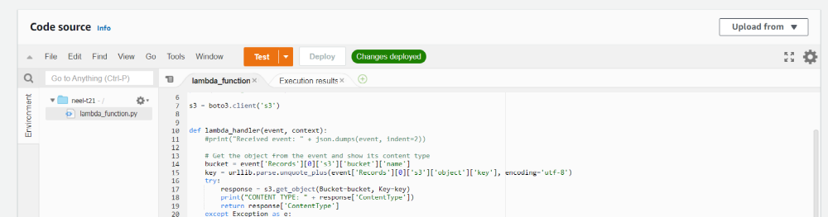
Now,
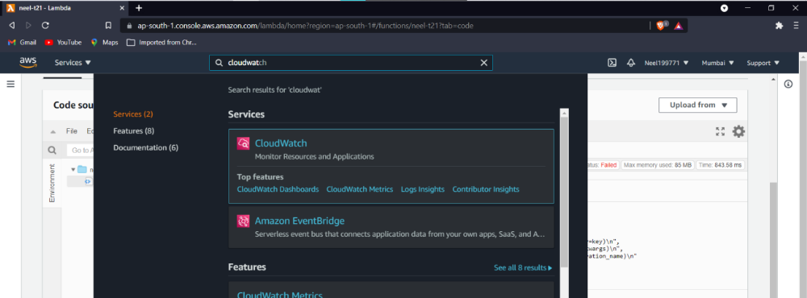
Check the logs of the test-
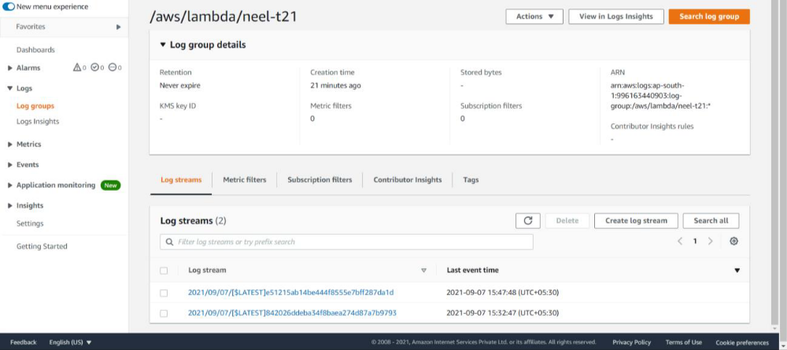
Now terminate-
Click on delete function.
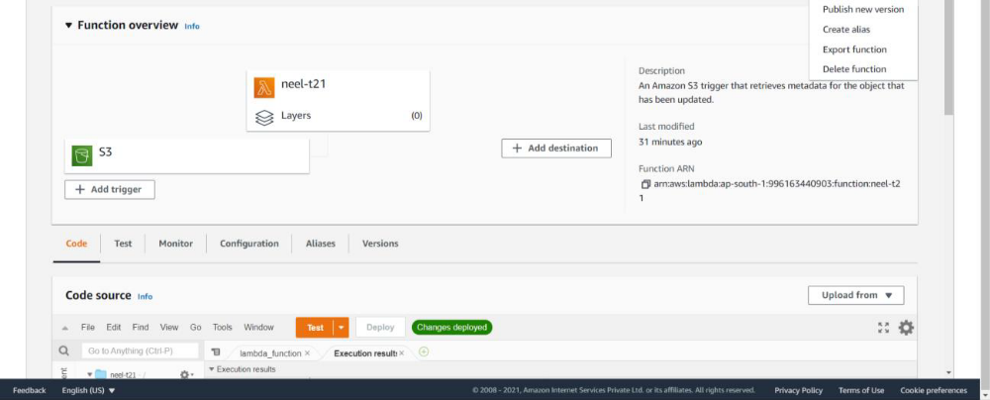
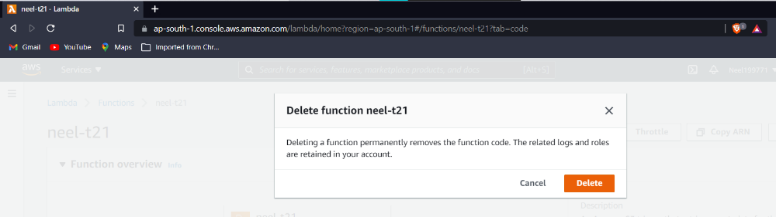
Empty bucket
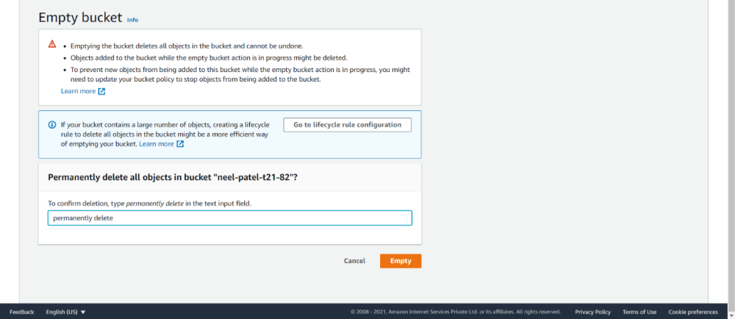
Delete bucket-
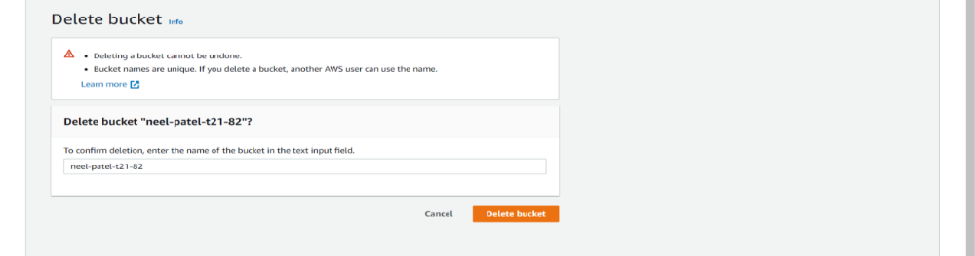
CONCLUSION:
In this assignment, we covered the core concepts and terminologies of AWS Lambda, explored its practical applications, and gained an understanding of how it integrates with various AWS services.

